CHALLENGE #11: How Tos

For this challenge, I'm excited to share the documentation because it turns out that's what we're looking for. My bad for misreading the instructions in the past challenges— oops! Anyway, in this challenge, the fun part is implementing 5 How-Tos in my project. I'll show you all of this by pasting some cool images or figures! I hope my score will not be “oops!” as well.

Figure 1/ How to 1: Rounded Avatar

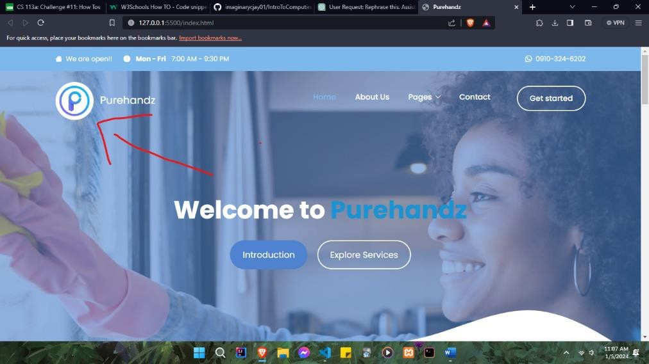

In figure 2 you can actually see that the homepage is a slideshow, but it’s automatic Figure 2/ How to 2: Slideshow

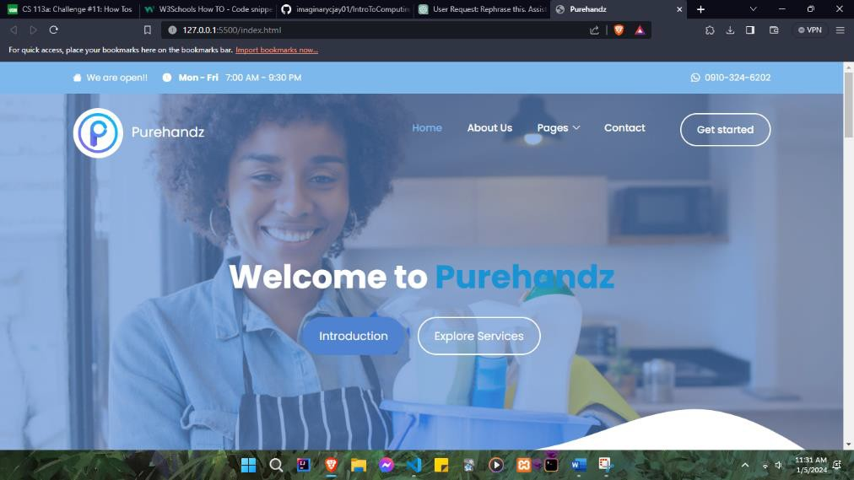

Figure 3/How to 3: A drop down

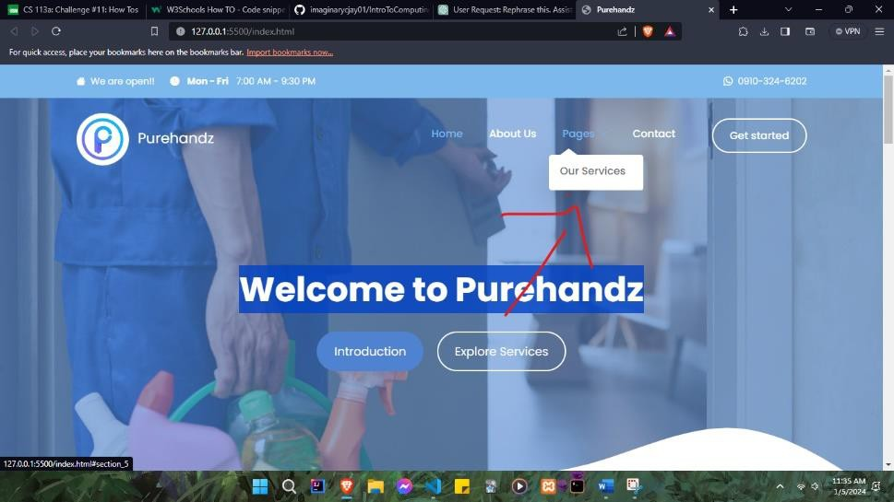

Figure 4/How to 4: Responsive Top Navigation

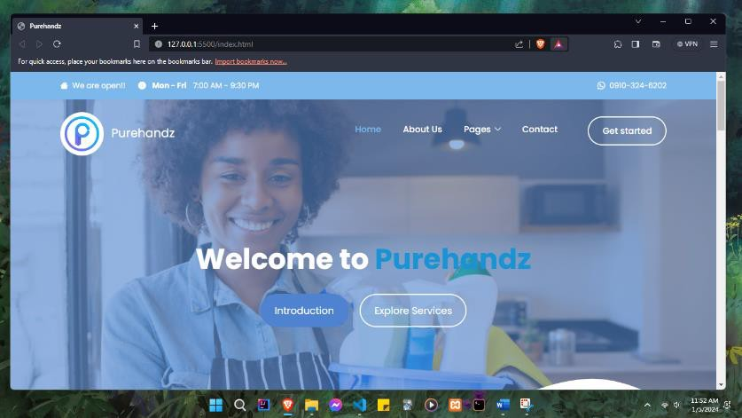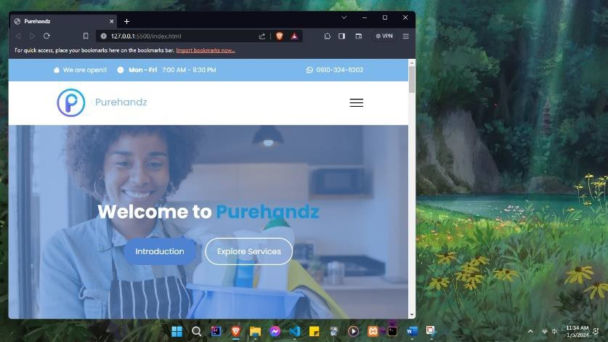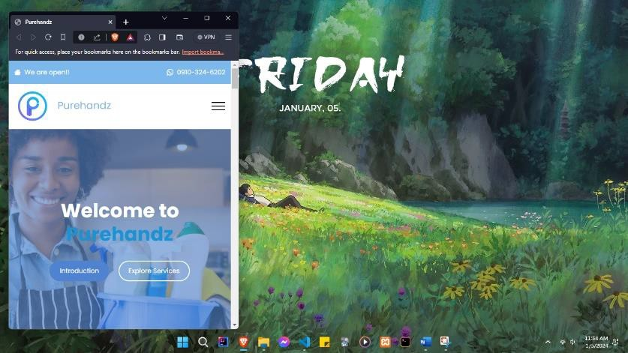

Figure 5/How to 5: Image Text Block

